MINI PROJECT-I REPORT

**On**

**Om Sai Building Materials,**

**A Shop Management System**

**Submitted by**

**Abhinav Varshney**

**171500005**

**Aman Singhal**

**171500038**

Department of Computer Engineering & Applications

**Institute of Engineering & Technology**



**GLA University**

**Mathura- 281406, INDIA**

**2019**

**Department of computer Engineering and Applications**

**GLA University, Mathura**

**17 km. Stone NH#2, Mathura-Delhi Road, P.O. – Chaumuha,**

**Mathura – 281406**



**Declaration**

I hereby declare that the work which is being presented in the Mini project -I “Om Sai Building Materials,A Shop Management System**”,** in partial fulfillment of the requirements for Mini Project-I viva voce, is an authentic record of my own work carried under the supervision of Mr.Neeraj Khanna,Technical Trainer,GLAU.

**CERTIFICATE**

This is to certify that the mini project report entitled "Alcohol Detection System" submitted by Manish Saraswat and Pranav Agarwal has been carried out under the guidance of Mr.Akash Chaudhary,Technical Trainer, Department of Computer

Engineering & Applications ,GLA University, Mathura.

**ACKNOWLEDGEMENT**

The project work in this report is an outcome of continuous work over a period and drew intellectual support from various sources. We would like to articulate our profound gratitude to all those people who extended their wholehearted co-operation and have helped me in completing this project successfully.

We are thankful to Mr.Akash Chaudhary for teaching and assisting us in making the project successful. We would also like to thank other fellow mates for guiding and encouraging me throughout the duration of the project.

**Manish Saraswat(171500181)**

**Pranav Agarwal (17500224)**

**ABSTRACT**

The aim of our mini project is to represent our project which makes human driving safer and to overcome accidents and to stop habit of alcohol consumption among students of university and colleges. This project is developed by integrating alcohol sensor with Arduino board. Arduino processor is able to handle more functions than conventional microcontrollers. The alcohol sensor used in this project is MQ3 which to detect the alcohol content in human breath. Since sensor has fine sensitivity range around 2 meters, it can suit to any vehicle and can easily be hidden from the suspects. This project is fitted inside the vehicle. The project is designed for the safety of people sitting inside the vehicle and to create alcohol free environment in university and colleges.

**Contents**

|  |  |
| --- | --- |
| Certificate | 3 |
| Acknowledgements | 4 |
| Abstract | 5 |
| 1. **Introduction** | **8** |
| 1.1 Overview …………………………………………………… | 8 |
| 1.2 Objective .………………………………………………….... | 9 |
| 1. **Software Development Tools** | **10** |
| 2.1 Operating System…………………………………….. | 10 |
| 2.2 Xampp Server……………………………….. | 10 |
| 2.3 MySQL ……………..………………………………… | 10 |
| 2.4 Android Studio………………………………………… |  |
| 1. **Introduction to PHP** | **12** |
| 3.1 Introduction ……………………….………………………… | 12 |
| 3.2 Installation and Basic Syntax………..…………………. | 13 |
| 1. **Introduction to CodeIgnitor** | **14** |
| 4.1 Introduction………….……………………………………… | 14 |
| 4.2 Installation ……………………..…………………. | 15 |
| 4.3 Architecture……………………………………….. | 16 |
| 1. **Introduction to Android** | **20** |
| 5.1 Introduction to Android Studio……………………………… | 20 |
| 5.2 Installation…………………………………………………. | 21 |
| 5.3 Basics of Android………………………………………… | 22 |
| 1. **Implementation and User Interface Backend** | **24** |
| 6.1 Description………………………………………………… |  |
| 6.2 Admin Portal……………………………………………….. |  |
| 6.3 Database Design…………………………………………….. |  |
| 6.4 API’s created……………………………………………… |  |
| 1. **Implementation and User Interface Frontend** |  |
| 7.1 Description | 24 |
| 7.2 User Interfaces | 27 |
| **References** | 35 |

**Chapter 01**

**Introduction**

1.1Overview

A college having a large campus and a large number of students who are involve in many types of addiction like drinking alcohol, smoking, marijuana. Due to this they are not only affecting their life but also creating a negative image of college in the society. Daily many students use to do this activity but due to unavailability of any sensor at hostels and main college gate, those students are never caught in their college life. Moreover, nowadays many accidents are taking place due to drinking of alcohol of driver and some time it become difficult to identify the student or person.

1.2 Objective

Drinking and driving is already a serious public health problem ,which is likely to emerge as one of the most significant problems in near future .the system implemented by us aims at reducing the road accident in the near future due to drunken and drive . This paper present the progress in using the alcohol detector ,a device that senses a change in the alcoholic gas content of the surrounding air these device is more commonly referred to as a breath analysis, as it analysis the alcohol content from person’s breath. The system detects the presence of alcohol in the vehicle and immediately locks the engine of the vehicle.

**Chapter 02**

**Software and development tools**

2.1 Arduino ide

The Arduino Integrated Development Environment (IDE) is a cross-platform application (for Windows, macOS, Linux) that is written in functions from C and C++. It is used to write and upload programs to Arduino compatible boards, but also, with the help of 3rd party cores, other vendor development boards.The source code for the IDE is released under the GNU General Public License, version .The Arduino IDE supports the languages C and C++ using special rules of code structuring.The Arduino IDE supplies a software library from the Wiring project, which provides many common input and output procedures. User-written code only requires two basic functions, for starting the sketch and the main program loop, that are compiled and linked with a program stub main() into an executable cyclic executive program with the GNU toolchain, also included with the IDE distribution. The Arduino IDE employs the program avrdude to convert the executable code into a text file in hexadecimal encoding that is loaded into the Arduino board by a loader program in the board's firmware.

2.2 Android Studio

Android Studio is the official integrated development environment (IDE) for Google's Android operating system, built on JetBrains' IntelliJ IDEA software and designed specifically for Android development. It is available for download on Windows, macOS and Linux based operating systems. It is a replacement for the Eclipse Android Development Tools (ADT) as the primary IDE for native Android application development.

Android Studio was announced on May 16, 2013 at the Google I/O conference. It was in early access preview stage starting from version 0.1 in May 2013, then entered beta stage starting from version 0.8 which was released in June 2014. The first stable build was released in December 2014, starting from version 1.0.

Features

The following features are provided in the current stable version:

Gradle-based build support

Android-specific refactoring and quick fixes

Lint tools to catch performance, usability, version compatibility and other problems

ProGuard integration and app-signing capabilities

Template-based wizards to create common Android designs and components

A rich layout editor that allows users to drag-and-drop UI components, option to preview layouts on multiple screen configurationsSupport for building Android Wear apps

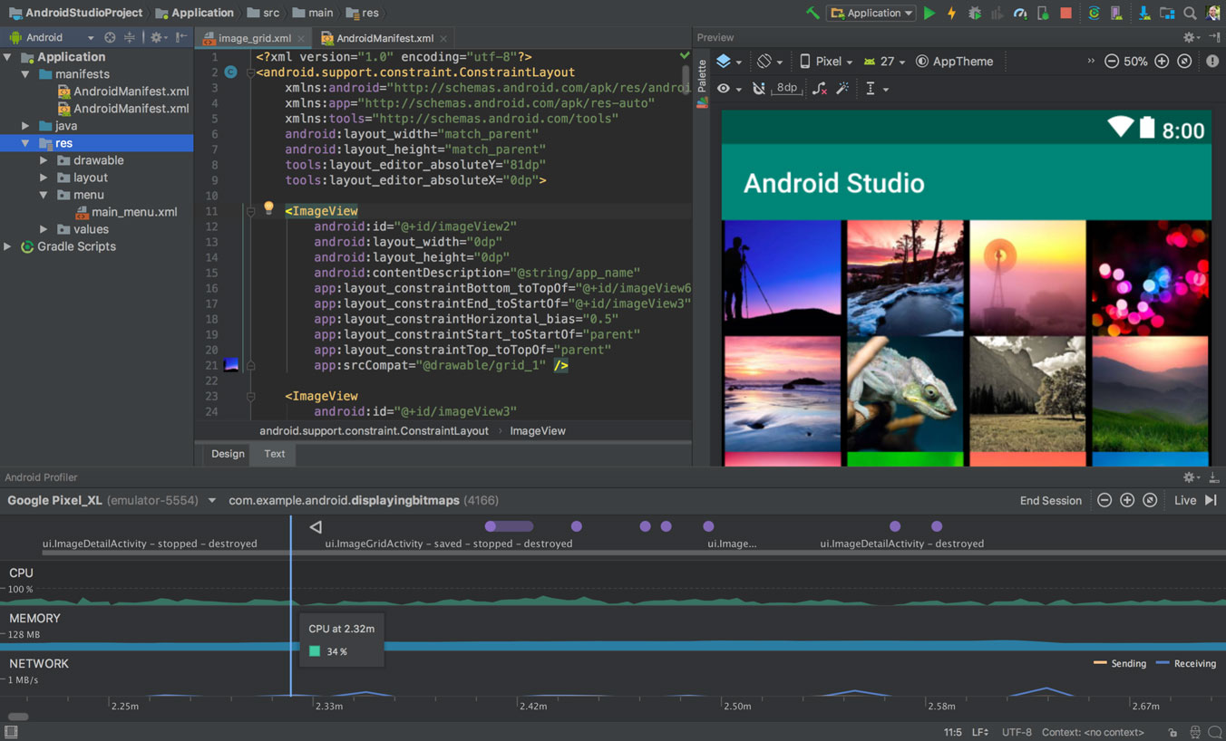

**Chapter 03**

**Literature Survey**

This project describes the alcohol detection system for vehicle by using alcohol sensor and arduino UNO.

This project discuss about the smart alcohol detection system using alcohol detection for vehicle protection.This paper introduces methods such as alcohol detection and personal identification system and discuss how they can be implemented to avoid accidents.Instead of using microcontrollers in this project we used Arduino.

In this project we discuss about driver’s behaviour,safety application & auto theft prevention system .This project represents identity detection system by image processing . In this paper they describe about body area sensing,alcohol detection craving .

In our paper we discuss about the alcohol detection system for vehicle using alcohol sensor MQ3 and buzzer using Arduino .

**Chapter 04**

**Problem Statement**

Drunken driving is considered as one of the major reason of accidents in worldwide. Drivers under the influence of alcohol shows a clear failure of perception recognition and vehicle control. So, by this accident occurs.

A college having a large campus and a large number of students who are involve in many types of addiction like drinking alcohol, smoking, marijuana. Due to this they are not only affecting their life but also creating a negative image of college in the society. Daily many students use to do this activity but due to unavailability of any sensor at hostels and main college gate, those students are never caught in their college life. Moreover, nowadays many accidents are taking place due to drinking of alcohol of driver and some time it become difficult to identify the student or person.

**Chapter 05**

**Introduction to Android**

5.1 Introduction to Android Studio

Android is a mobile operating system developed by Google. It is based on a modified version of the Linux kernel and other open source software, and is designed primarily for touchscreen mobile devices such as smartphones and tablets. In addition, Google has developed Android TV for televisions, Android Auto for cars, and Wear OS for wrist watches, each with a specialized user interface. Variants of Android are also used on game consoles, digital cameras, PCs and other electronics.

Initially developed by Android Inc., which Google bought in 2005, Android was unveiled in 2007, with the first commercial Android device launched in September 2008. The current stable version is Android 9 "Pie", released in August 2018. Google released the first beta of the next release, Android Q, on Pixel phones in March 2019. The core Android source code is known as Android Open Source Project (AOSP), which is primarily licensed under the Apache License.

Features:

Interface

Applications

Memory management

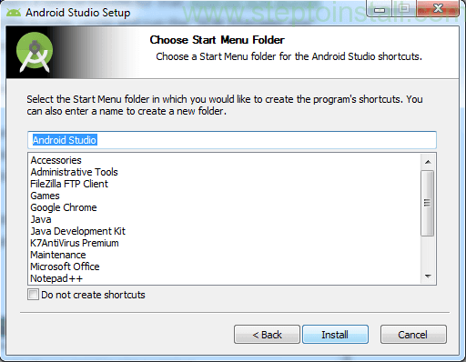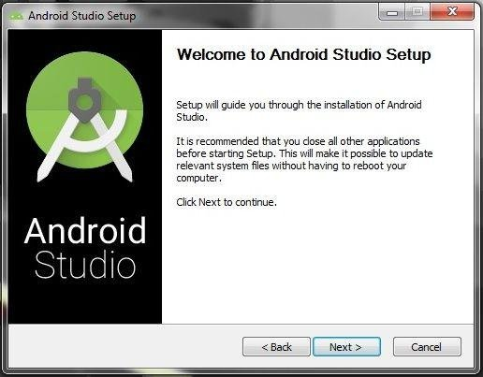5.2 Installation

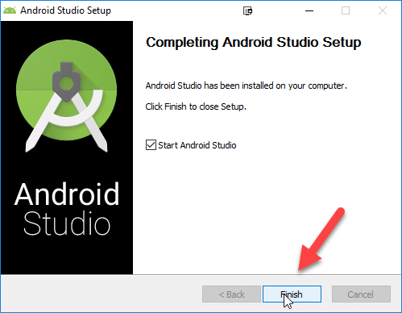

5.3 Basics of Android

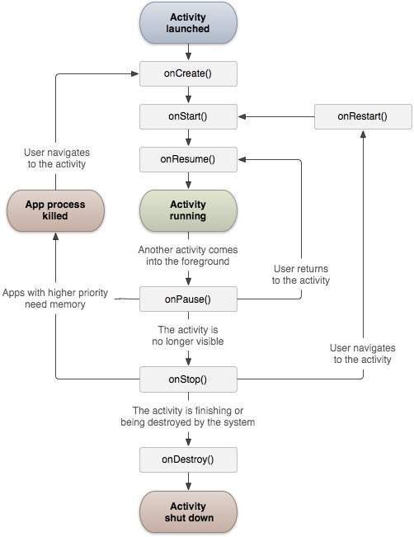

The basic building block for user interface is a View object which is created from the View class and occupies a rectangular area on the screen and is responsible for drawing and event handling. View is the base class for widgets, which are used to create interactive UI components like buttons, text fields, etc.

The ViewGroup is a subclass of View and provides invisible container that hold other Views or other ViewGroups and define their layout properties.

At third level we have different layouts which are subclasses of ViewGroup class and a typical layout defines the visual structure for an Android user interface and can be created either at run time using View/ViewGroup objects or you can declare your layout using simple XML file main_layout.xml which is located in the res/layout folder of your project.

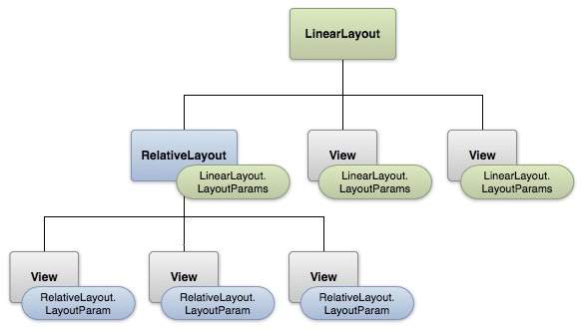

**Chapter 06**

**Introduction to Arduino IDE**

6.1 Description

* Arduino IDE is an open source software that is mainly used for writing and compiling the code into the Arduino Module.
* It is an official Arduino software, making code compilation too easy that even a common person with no prior technical knowledge can get their feet wet with the learning process.
* It is easily available for operating systems like MAC, Windows, Linux and runs on the Java Platform that comes with inbuilt functions and commands that play a vital role for debugging, editing and compiling the code in the environment.
* A range of Arduino modules available including Arduino Uno, Arduino Mega, Arduino Leonardo, Arduino Micro and many more.
* Each of them contains a microcontroller on the board that is actually programmed and accepts the information in the form of code.
* The main code, also known as a sketch, created on the IDE platform will ultimately generate a Hex File which is then transferred and uploaded in the controller on the board.
* The IDE environment mainly contains two basic parts: Editor and Compiler where former is used for writing the required code and later is used for compiling and uploading the code into the given Arduino Module.
* This environment supports both C and C++ languages.

6.2 How to download Arduino IDE

You can download the Software from Arduino main website. As I said earlier, the software is available for common operating systems like Linux, Windows, and MAX, so make sure you are downloading the correct software version that is easily compatible with your operating system.

If you aim to download Windows app version, make sure you have Windows 8.1 or Windows 10, as app version is not compatible with Windows 7 or older version of this operating system.

The IDE environment is mainly distributed into three sections

1. Menu Bar

2. Text Editor

3. Output Pane

As you download and open the IDE software, it will appear like an image below.

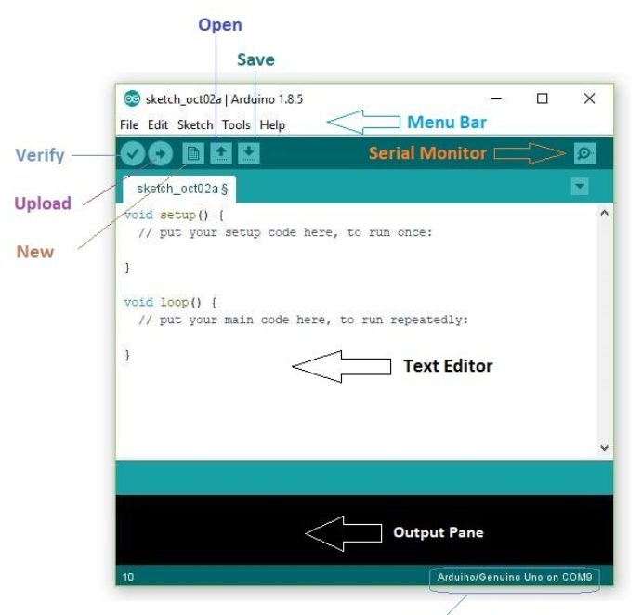

The bar appearing on the top is called Menu Bar that comes with five different options as follow:

File – You can open a new window for writing the code or open an existing one. Following table shows the number of further subdivisions the file option is categorized into.

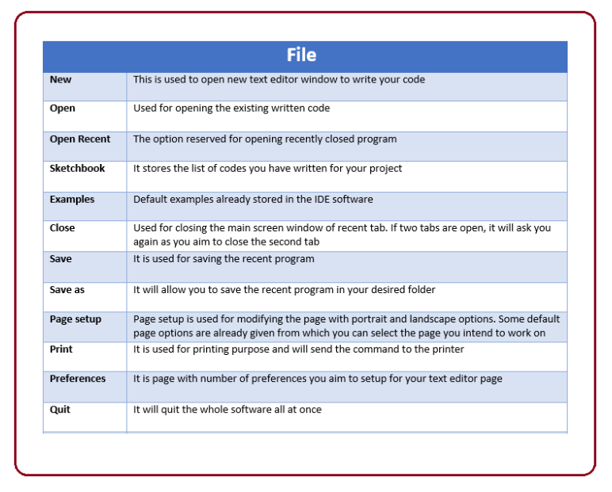

As you go to the preference section and check the compilation section, the Output Pane will show the code compilation as you click the upload button.

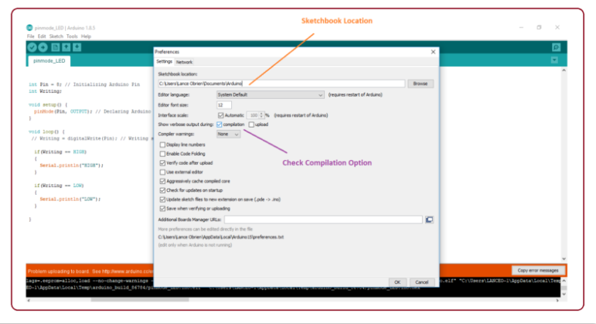

And at the end of compilation, it will show you the hex file it has generated for the recent sketch that will send to the Arduino Board for the specific task you aim to achieve.

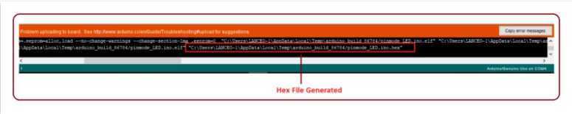

Edit – Used for copying and pasting the code with further modification for font

Sketch – For compiling and programming

Tools – Mainly used for testing projects. The Programmer section in this panel is used for burning a bootloader to the new microcontroller.

Help – In case you are feeling skeptical about software, complete help is available from getting started to troubleshooting.

The Six Buttons appearing under the Menu tab are connected with the running program as follow.

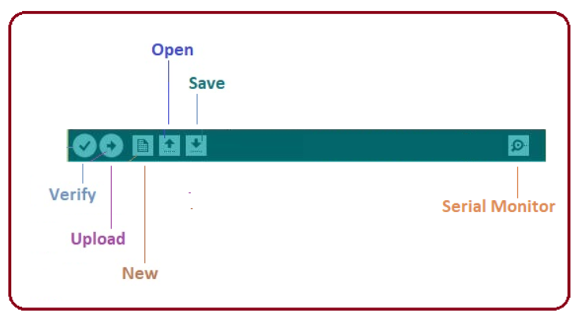

The check mark appearing in the circular button is used to verify the code. Click this once you have written your code.

The arrow key will upload and transfer the required code to the Arduino board.

The dotted paper is used for creating a new file.

The upward arrow is reserved for opening an existing Arduino project.

The downward arrow is used to save the current running code.

The button appearing on the top right corner is a Serial Monitor – A separate pop-up window that acts as an independent terminal and plays a vital role for sending and receiving the Serial Data. You can also go to the Tools panel and select Serial Monitor, or pressing Ctrl+Shift+M all at once will open it instantly. The Serial Monitor will actually help to debug the written Sketches where you can get a hold of how your program is operating. Your Arduino Module should be connected to your computer by USB cable in order to activate the Serial Monitor.

You need to select the baud rate of the Arduino Board you are using right now. For my Arduino Uno Baud Rate is 9600, as you write the following code and click the Serial Monitor, the output will show as the image below

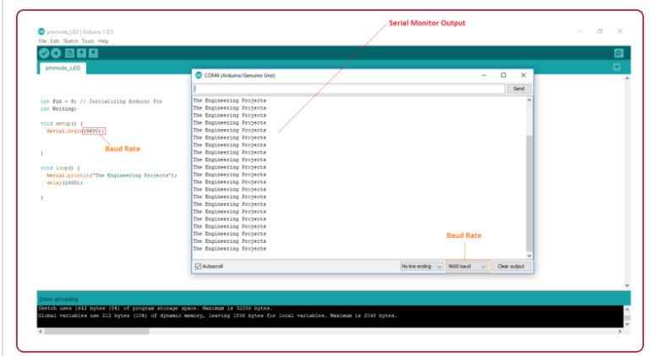

**Chapter 07**

**Proposed System**

Alcohol detection system is continuously growing over years which could resolve drunken driving accidents worldwide.

7.1 Hardware Module-

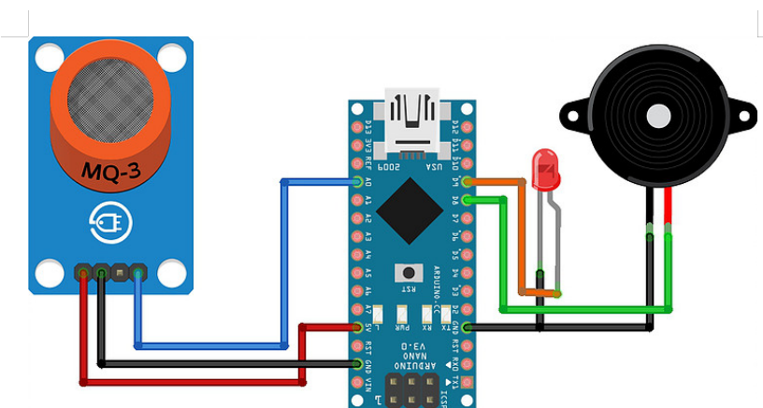

The entire system adopted the Arduino uno microcontroller board (Based on ATMEGA 328 ), the

principle of the hardware chart as shown in figure. The core functions modules are Arduino uno alcohol sensor module(MQ3), LCD display, buzzer, relay.

ARDUINO:- The arduino board is the central unit of the system. all the components are interface to the board and programmed as per their functionality to operate in synchronization .

ALCOHOL MODULE:- It is used to sense the alcohol. The analog output of which is applied to the arduino board.

LCD:- If alcohol is detected it displays the message indicating “alcohol detected”.

**Arduino Board-**

The arduino board is the central unit of the system. The arduino uno is the microcontroller board based on the ATmega 328. It is a programmable microcontroller for prototyping electromechanical devices.it has 14 digital inputs/output pins (of which 6 can be used as PWM output),6 analog inputs , a 16 MHz ceramic resonators the arduino differs from all preceding board is that it does not use the FTDI USB to serial driver chip.

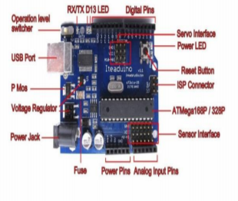

Features-

Microcontroller ATmega328

Operating Voltage 5V

Input Voltage 7-12V

Input Voltage (limits) 6-20V

Digital I/O Pins 14

Analog Input Pins 6

DC Current per I/O Pin 40 mA

DC Current for 3.3V Pin 50 mA

Flash Memory 32 KB (ATmega328)

SRAM 2 KB (ATmega328)

EEPROM 1 KB (ATmega328)

Clock Speed 16 MHz

**Alcohol Sensor-**

The analog gas sensor- MQ3 is suitable for alcohol detecting, this sensor can be used in a breath analyzer. It has a high sensitivity to alcohol and small sensitivity to benzene. The sensitivity can be adjusted by the potentiometer sensitive material of MQ3 gas sensor is SnO2, which with lower conductivity in clean air. When the target alcohol gas exist, the sensors conductivity is higher along with the gas concentration rising, use of simple electro circuit, convert change of conductivity to correspond output signal of gas concentration.

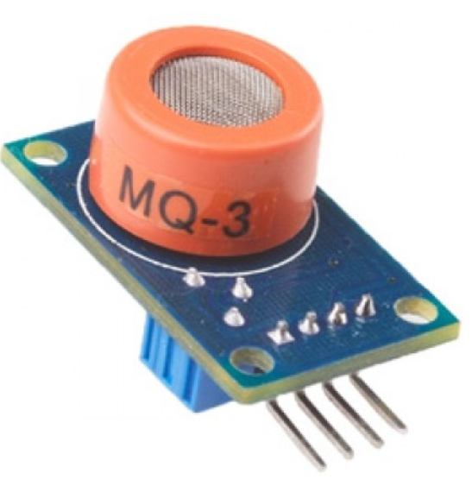

MQ-3 gas sensor has high sensitivity to Alcohol, and has good resistance to disturb of gasoline, smoke and vapour. It has fine sensitivity range around 2 meters. The sensor could be used to detect alcohol with different concentration; it is with low cost and suitable for different application.

**Sensitivity Adjustment-**

Resistance value of MQ-3 is difference to various kinds and various concentration gases. So, when using these components, sensitivity adjustment is very necessary. It is recommended to calibrate the detector for 0.4mg/L (approximately 200ppm) of Alcohol concentration in air and use value of Load resistance that (RL) about 200 KΩ (100KΩ to 470KΩ). When accurately measuring, proper alarm point for the gas detector has to be determined after considering the temperature and humidity influence.

Character Configuration-

1. Good sensitivity to alcohol gas.

2. Circuit is simply driven.

3. Low cost and long life

4. Small towards benzene and High sensitivity to

alcohol .

5. Fast response and high sensitivity and stability and

long life.

**Specifications-**

1. Power supply requires 5 volts.

2. Interference type: analog only.

3. Pin specification: 1-output, 2-GND, 3-VCC

4. High sensitivity and fast response.

5. Stable and long life

6. Small towards benzene and High sensitivity to alcohol

Simple drive circuit with size:40*20mm.

**Buzzer-**

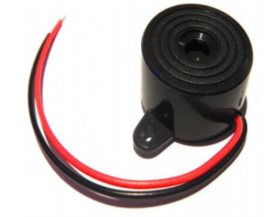

Features-

1. The PS series are high performance buzzers that employ uni-morph piezoelectric elements and are designed for easy incorporation into various circuits.
2. They feature extremely low power consumption in comparison to electromagnetic units.
3. Because these buzzers are designed for external excitation, the same part can serve as both a musical tone oscillator and a buzzer.
4. They can be use with automated inserters, moistureresistant models are also available.

**7.2 System Flow Chart-**

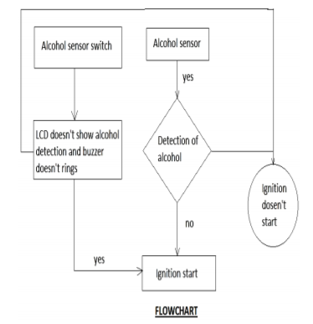

**E-R Diagram-**

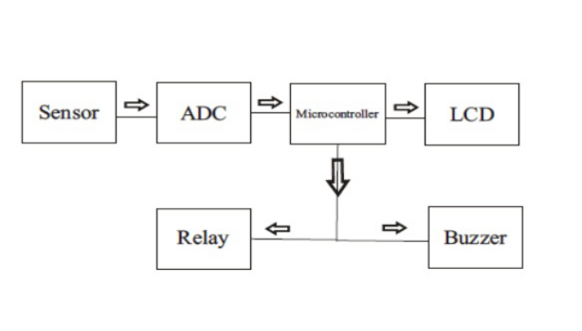

**Advantages-**

1. To prevent accident due to drunk and driving.

2. Easy and efficient to test the alcohol content in the body.

3. Quick and accurate results.

4. Helpful for police and provides and automatic safety

systems for cars and other vehicles as well.

**Applications-**

1. “Alcohol detector project” can be used in the various vehicles for detecting whether the driver as consumed alcohol or not.

2. This project can also be used in various companies or organizations to detect alcohol consumptions of employees.

**Chapter 08**

**Results and Discussions-**

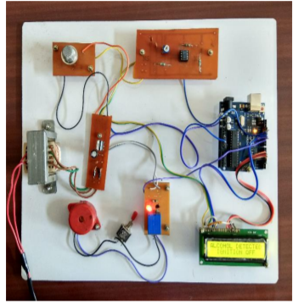

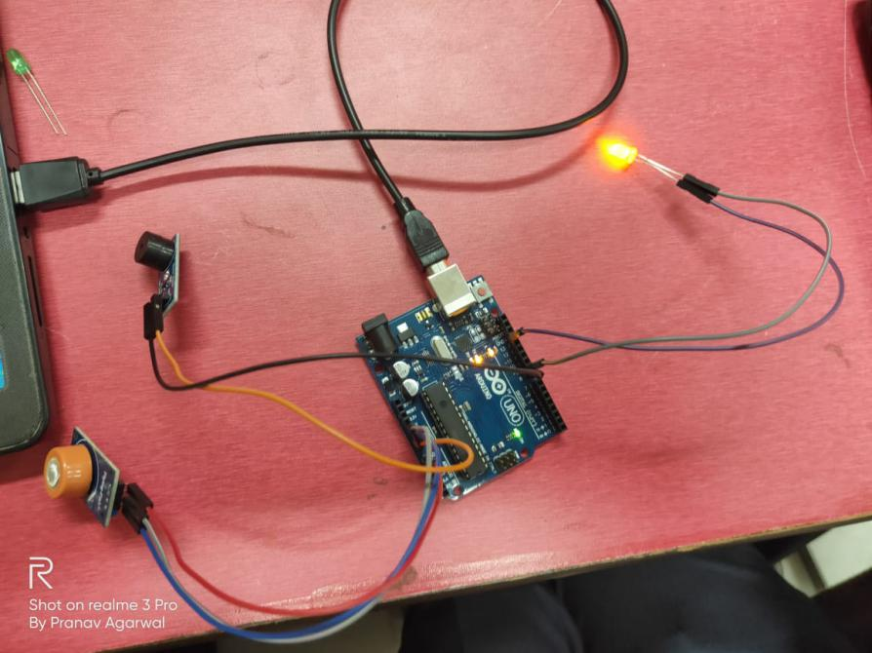

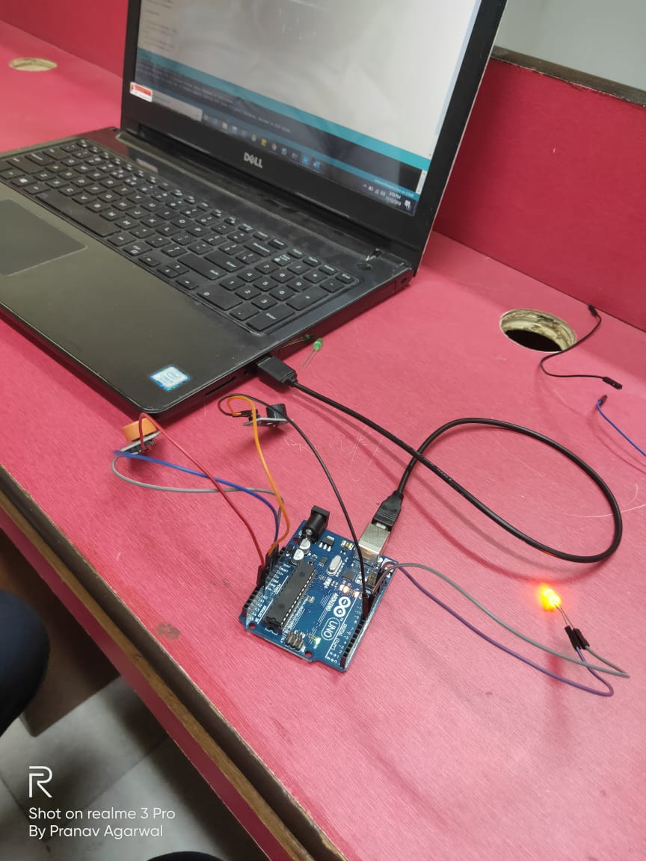

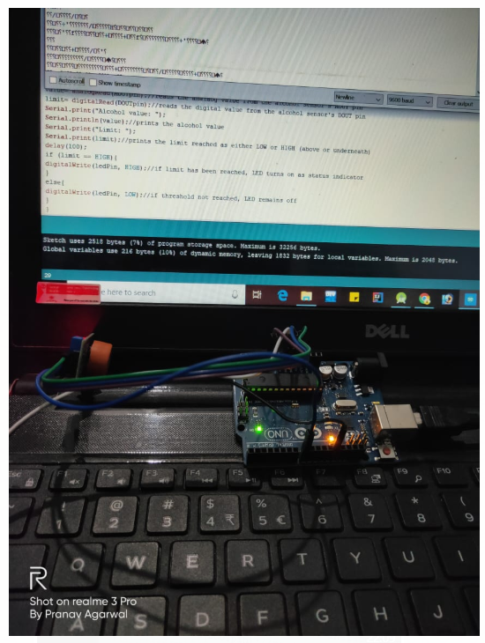

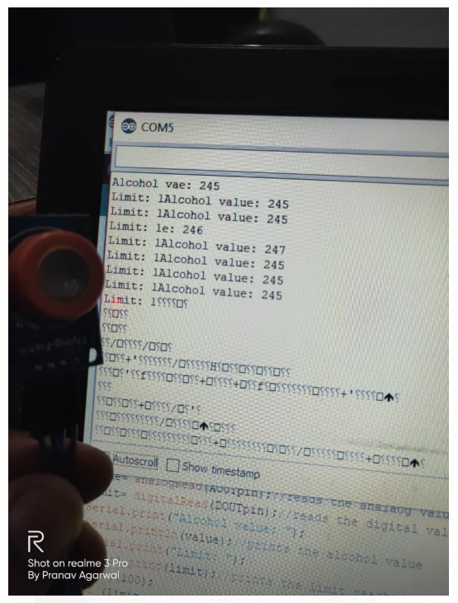

When the drunken driver enters in the vehicle alcohol sensor senses the alcohol, therefore buzzer rings and LCD displays that alcohol is detected as shown in fig.6 and ignition of vehicle automatically turns off by relay. So, by this the purpose of our project succeeds.

**Chapter 09**

**Conclusions**

We have provided a very effective solution to develop an intelligent system for vehicles for alcohol detection whose core is Arduino. Since sensor has fine sensitivity range around 2 meters, it can suit to any vehicle and can easily be hidden from the suspects. The whole system has also an advantage of small volume and more reliability. As the growing public perception is that vehicle safety is more important, advances in public safety is gaining acceptance than in the past. Future scope of this system is to control the accidents causes due to alcohol consumption. This system improves the safety of human being. And hence providing the effective development in the automobile industry regarding to reduce the accidents cause due to alcohol.

**Chapter 10**

**Appendix**

Source Code-

const int AOUTpin=0;//the AOUT pin of the alcohol sensor goes into analog pin A0 of the arduino  
const int DOUTpin=8;//the DOUT pin of the alcohol sensor goes into digital pin D8 of the arduino  
const int ledPin=13;//the anode of the LED connects to digital pin D13 of the arduino  
  
int limit;  
int value;  
  
void setup() {  
Serial.begin(115200);//sets the baud rate  
pinMode(DOUTpin, INPUT);//sets the pin as an input to the arduino  
pinMode(ledPin, OUTPUT);//sets the pin as an output of the arduino  
}  
  
void loop()  
{  
value= analogRead(AOUTpin);//reads the analaog value from the alcohol sensor's AOUT pin  
limit= digitalRead(DOUTpin);//reads the digital value from the alcohol sensor's DOUT pin  
Serial.print("Alcohol value: ");  
Serial.println(value);//prints the alcohol value  
Serial.print("Limit: ");  
Serial.print(limit);//prints the limit reached as either LOW or HIGH (above or underneath)  
delay(100);  
if (limit == HIGH){  
digitalWrite(ledPin, HIGH);//if limit has been reached, LED turns on as status indicator  
}  
else{  
digitalWrite(ledPin, LOW);//if threshold not reached, LED remains off  
}  
}

**References**

1. [www.javatpoint.com](http://www.javatpoint.com)
2. <https://cloud.google.com/iot/docs/>
3. <https://developer.android.com/docs>
4. <https://dart.dev/guides>
5. <https://flutter.dev/docs>
6. www.youtube.com